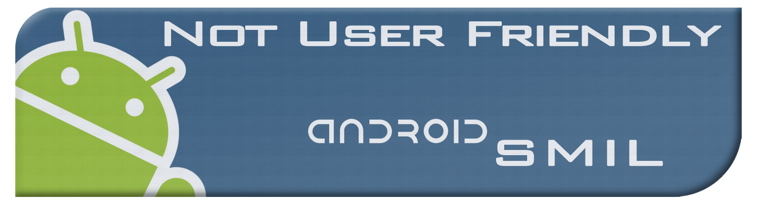

CSC 440

Week 2 1/19/2012  
E-Mail: [Barkerb1@nku.edu](mailto:Barkerb1@nku.edu)

Meeting Minutes

Attendees:

Brad Barker

Alex Gilbert

Jacob Ensor

Chris Bond

Next Meeting:

1/26/2012

Time:

4:50-6:05pm

Meeting Called By:

Brad Barker

Type of Meeting:

Solution Investigation

Facilitator:

Brad Barker

|  |  |  |
| --- | --- | --- |
| |  |  | | --- | --- | | Topics |  | |
| |  | | --- | | **Objectives:** | | 1. SMIL Language  2. Cloud Service  3. Roles |  |  | | --- | | **Status:** | | 1. We need to determine which elements and features of the SMIL language we are going to implement  2. Google or Amazon that is the question?  3. Strengths and weaknesses of the team? |  |  | | --- | | **Outcomes:** | | 1. Everyone Research SMIL for the next meeting, dilute the specification to a manageable level  2. Google cloud is free and designed to interface with the Android platform. It’s also free!  3. Brad: Lead, Implementer  Alex: Configuration Manager, Tester  Jacob: UI developer  Chris: System developer | | **Other Information:** | | We need to research the Cloud API, begin creating user stories, and start sketching user interface designs. Our git repo is setup and available on at <https://github.com/CSC440NotUserFriendly/Not_User_Friendly>. Be sure to include detailed comments with all commits. |  |  |  |  | | --- | --- | --- | | **Action Items:** | **Person Responsible:** | **Deadline:** | | Alex | Determine testing methods | 1/26/2012 | | Jacob | Sketch UI ideas | 1/26/2012 | | Chris | Research google API | 1/26/2012 | | Everyone | Create user stories | 1/26/2012 | |